**CSE3052 - INFORMATION SECURITY MANAGEMENT**

**DIGITAL ASSIGNMENT-1**

**ALOKAM NIKHITHA**

**19BCE2555**

**Experiment-1**

**TITLE:**

Connecting to Vlans.

**AIM:**

To Connect two different VLANS using switches.

**PROCEDURE:**

* Select 2 Switches Switch0, Switch1.And Select 4 PCs
* Connect the First 2 PCs to the Switch0 and next 2 to the Switch1.
* Give the IP address for PCs

PC1 : 192.168.1.1

PC2 : 192.168.1.2

PC3 : 192.168.1.3

PC4 : 192.168.1.4

* Configure both the Switches.
* Set the hostname of Switch0 as s1.
* Set the hostname of Switch1 as s2.
* Give the ip address to Switch0 and Switch1 as 10.0.0.1 255.0.0.0 and 10.0.0.2 255.0.0.0 respectively.
* Pass message from the PC0 to PC3.
* Event list provides the passage of message between the components
* PDU List window shows the status of the message If it is in progress or Successful.

**TOPOLOGY**

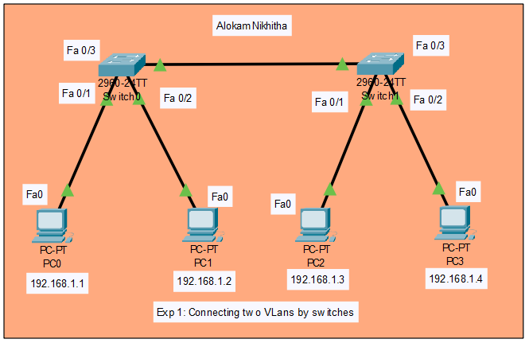

# **PC/ Computer Configuration:**

PC0 : 192.168.1.1

PC1 : 192.168.1.2

PC2 : 192.168.1.3

PC3 : 192.168.1.4

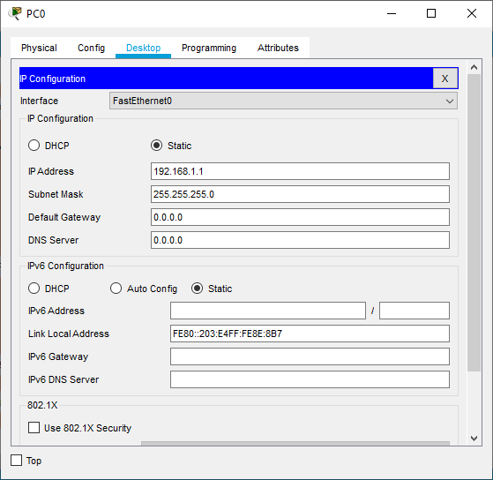

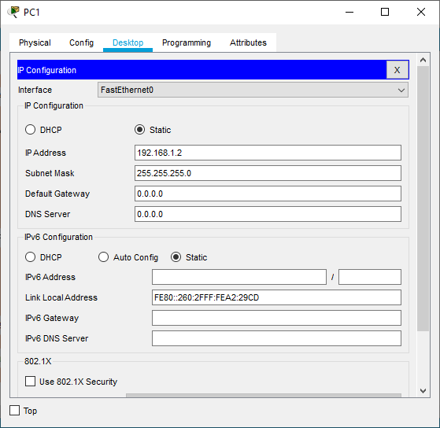

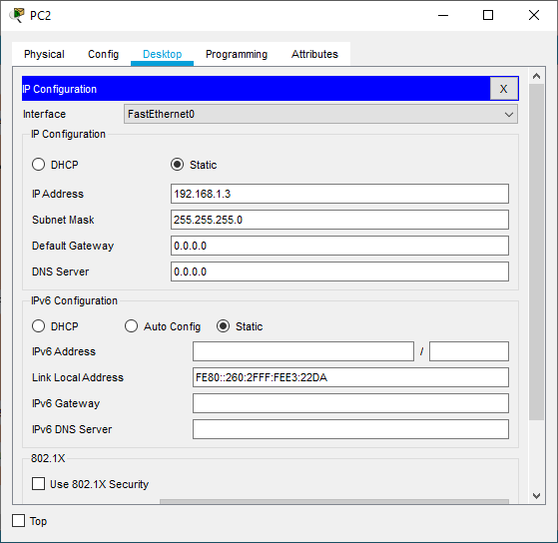

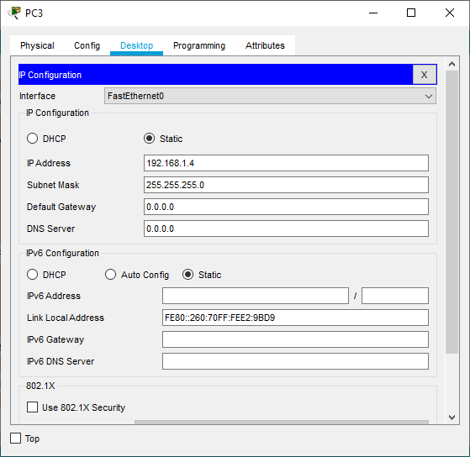

# **Switches Configuration:**

**Switch 0:**

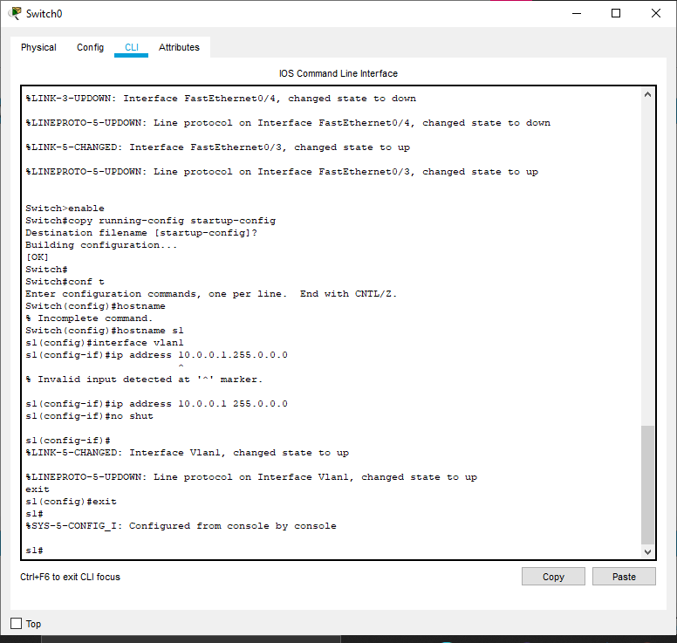

**Switch 1:**

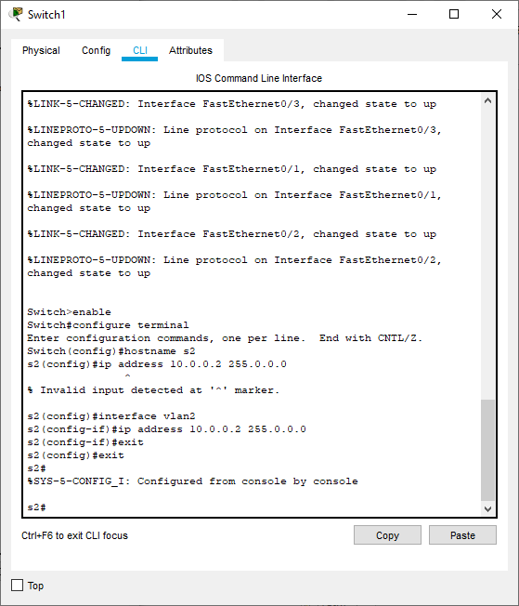

**SIMULATION**

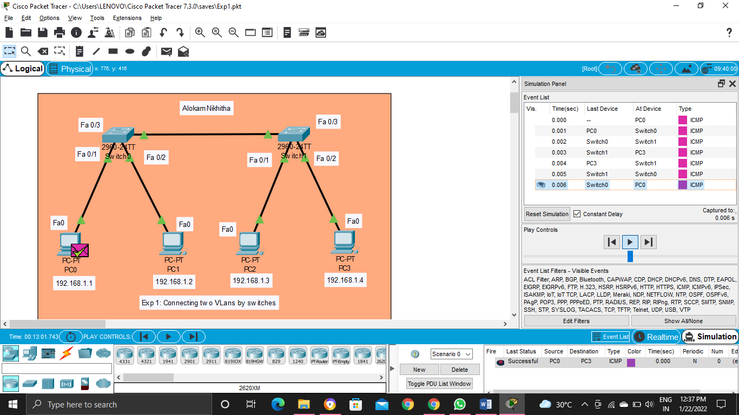



**Event List**

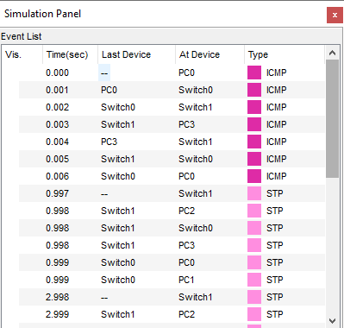

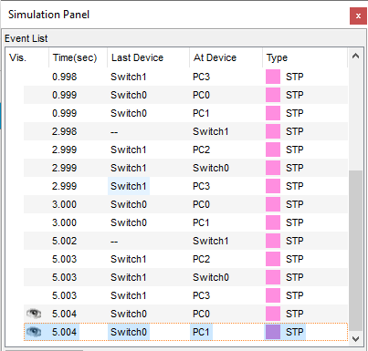

**Result**

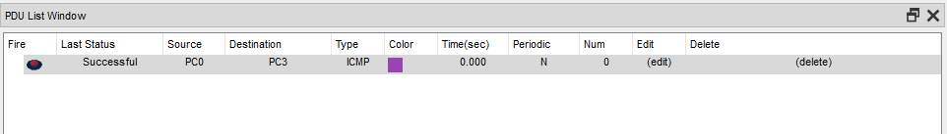

**Conclusion**

After completing the config in this lab we will get to know that VLANs allow network administrators to automatically limit access to a specified group of users by dividing workstations into different isolated LAN segments. When users move their workstations, administrators don't need to reconfigure the network or change VLAN groups.

**Experiment-2**

**TITLE:**

Connecting two different LANS using a router and switches

AIM:

To connect two different LANS using a router and switches configuration .

**PROCEDURE:**

* Select a 2911 Router
* Select 2960 2 switches and connect them to the router using Straight-through
* Select straight through cable from router select gigabitethernet 0/0 to switch0 gigabitethernet 0/1 and from router select gigabitethernet 0/1 to switch1 gigabitethernet 0/1
* Select 3 PCs and connect them to the switches in each network.
* Give addresses for Pcs in Network1 as : 192.168.1.11 to 192.168.1.13
* Give addresses for Pcs in Network2 as : 192.168.2.11 to 192.168.2.13
* Set default gateway for the Network 1 as 192.168.1.1 (as Similar to router gigabitEthernet 0/0)
* Set default gateway for the Network 2 as 192.168.2.1 (as Similar to router gigabitEthernet 0/1).
* Pass message from PC0 in Network1 to PC5 in Network 2
* Event list provides the passage of message between the components
* PDU List window shows the status of the message If it is in progress or Successful.

**TOPOLOGY**

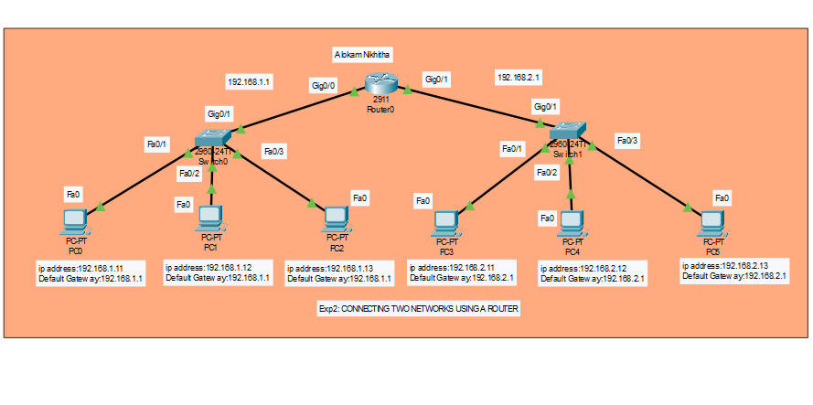**PC/ Computer Configuration:**

**PC0**

Ip Address: 192.168.1.11

Default Gateway:192.168.1.1

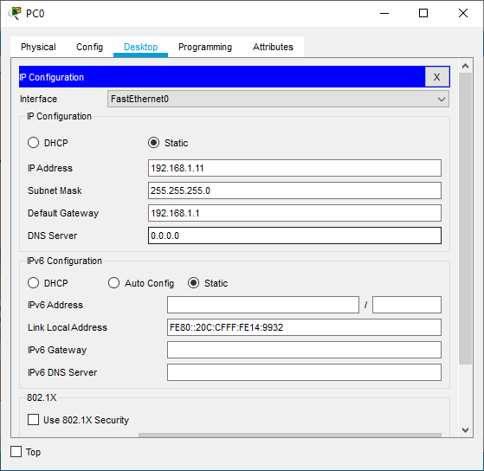

**PC1**

Ip Address: 192.168.1.12

Default Gateway:192.168.1.1

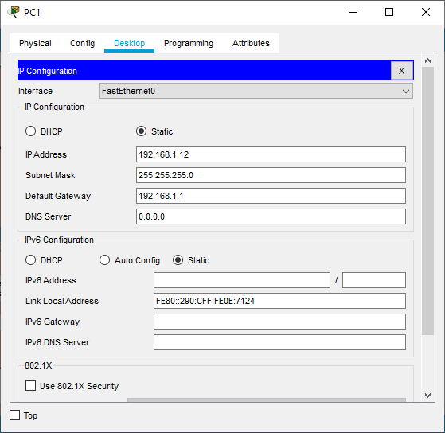

**PC2**

Ip Address: 192.168.1.13

Default Gateway:192.168.1.1

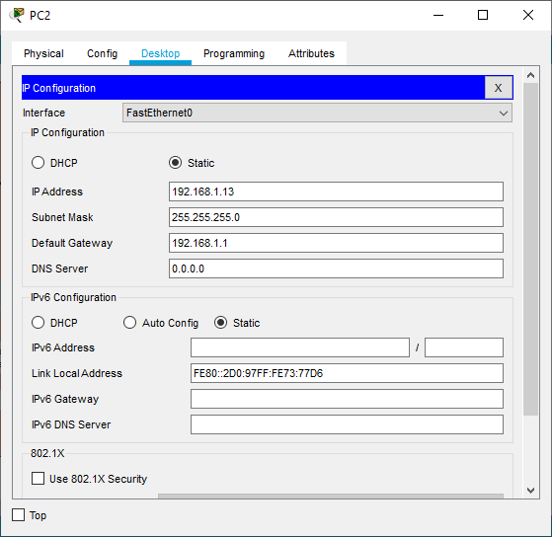

**PC3**

Ip Address: 192.168.2.11

Default Gateway:192.168.2.1

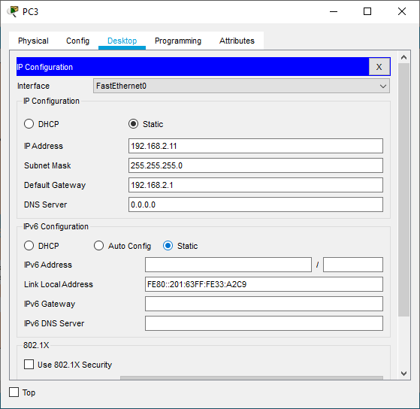

**PC4**

Ip Address: 192.168.2.12

Default Gateway:192.168.2.1

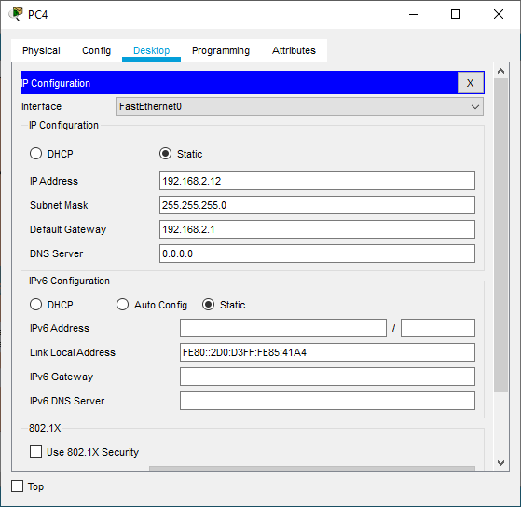

**PC5**

Ip Address: 192.168.2.13

Default Gateway:192.168.2.1

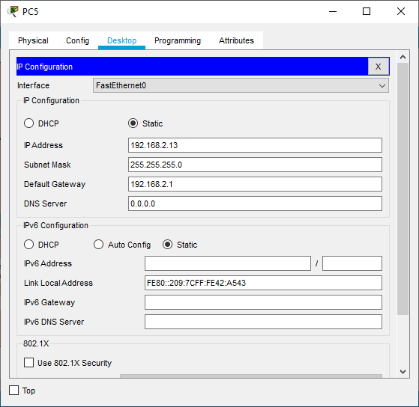

**Router Configuration:**

**Router 0:**

**CLI commands:**

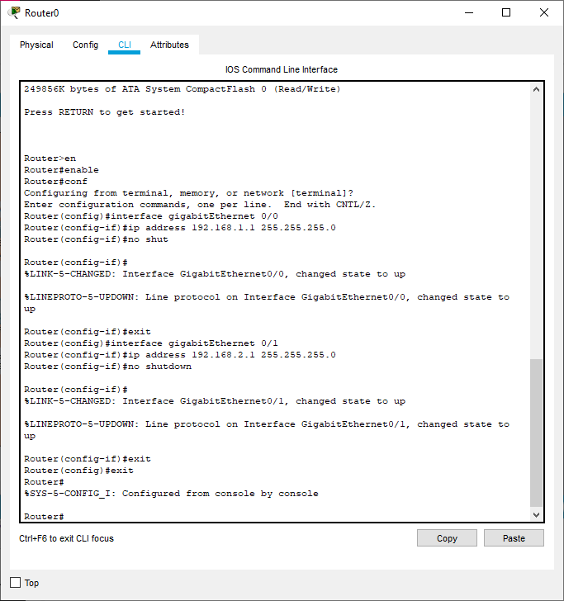

**SIMULATION**

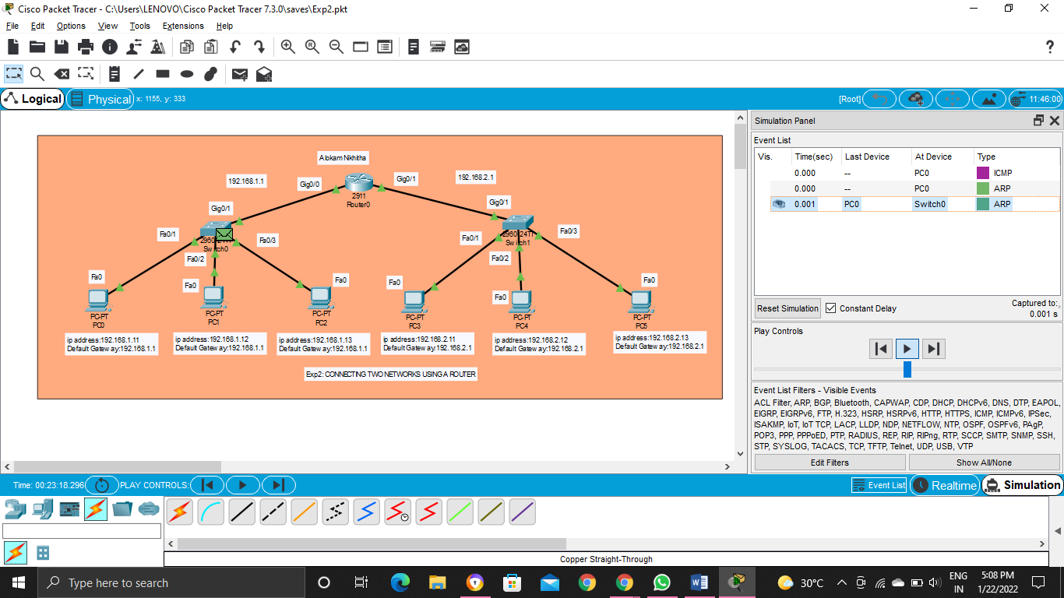

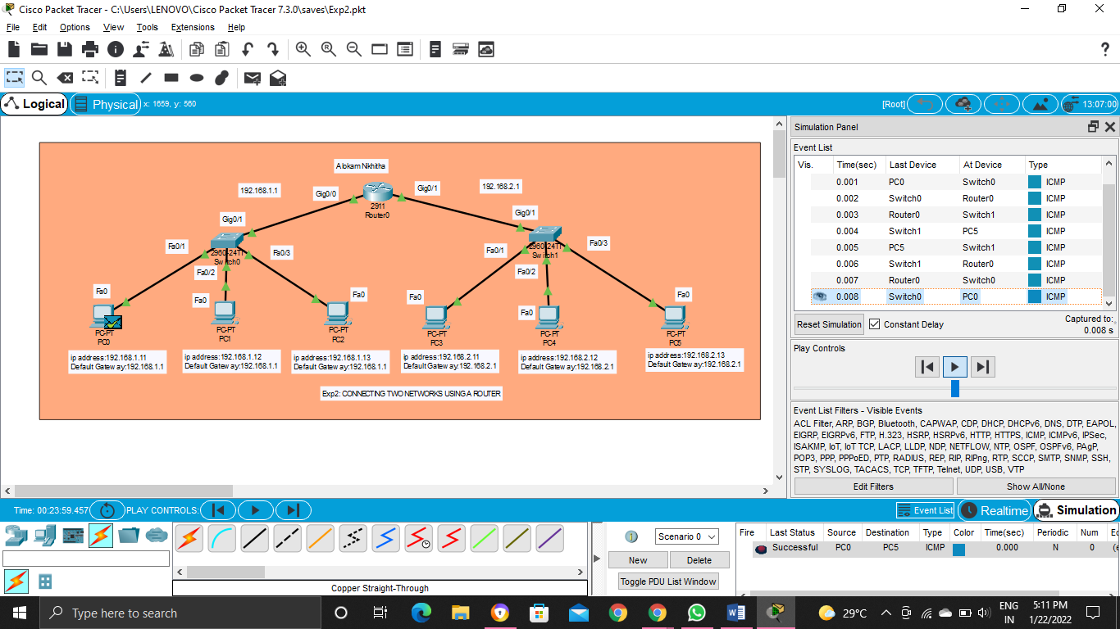

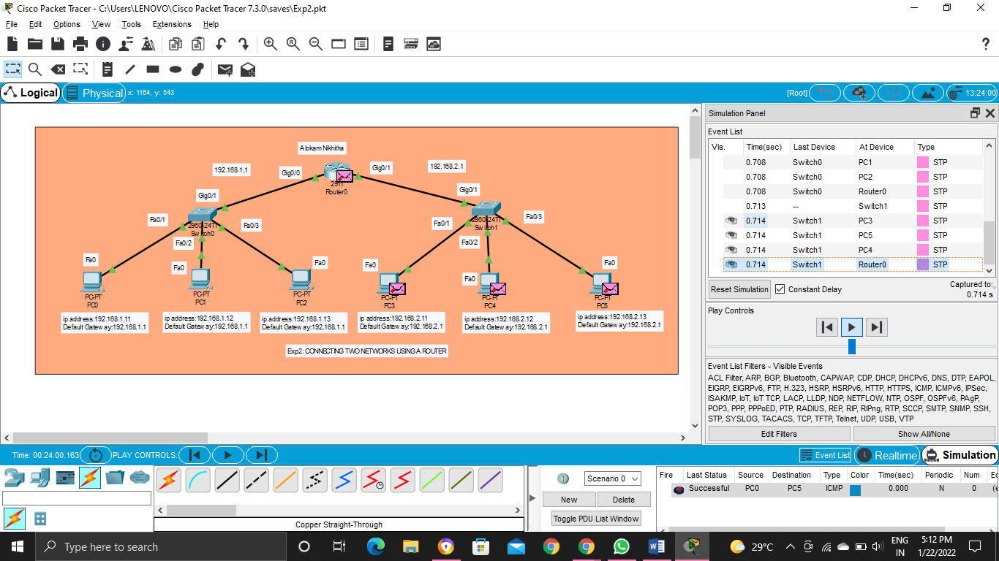

**Event List**

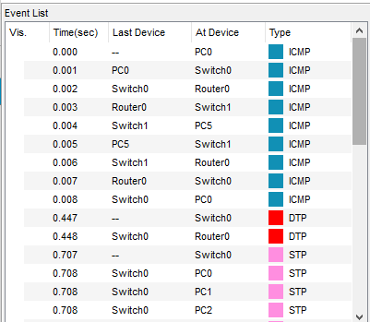

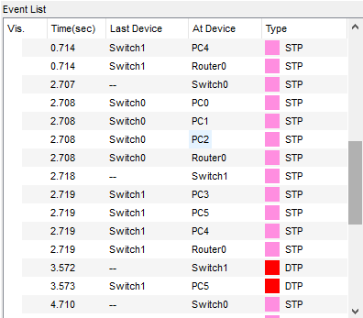 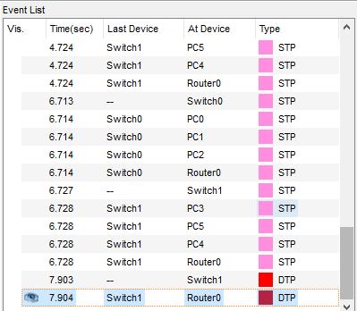

**Results**

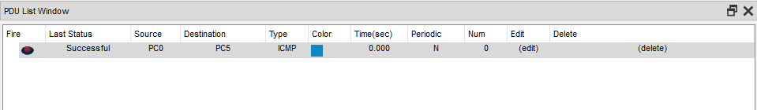

**Conclusion**

To create two LANs and connect them with Cisco routers and switches. Basic commands for Cisco devices are demonstrated in this lab. Upon completing the Lab, students should know how to create a small office wide network.